Design a Tic-Tac toe game in swing

import java.util.Arrays;

import java.util.InputMismatchException;

import java.util.Scanner;

public class CFG {

static String[] board;

static String turn;

// CheckWinner method will

// decide the combination

// of three box given below.

static String checkWinner()

{

for (int a = 0; a < 8; a++) {

String line = null;

switch (a) {

case 0:

line = board[0] + board[1] + board[2];

break;

case 1:

line = board[3] + board[4] + board[5];

break;

case 2:

line = board[6] + board[7] + board[8];

break;

case 3:

line = board[0] + board[3] + board[6];

break;

case 4:

line = board[1] + board[4] + board[7];

break;

case 5:

line = board[2] + board[5] + board[8];

break;

case 6:

line = board[0] + board[4] + board[8];

break;

case 7:

line = board[2] + board[4] + board[6];

break;

}

//For X winner

if (line.equals("XXX")) {

return "X";

}

// For O winner

else if (line.equals("OOO")) {

return "O";

}

}

for (int a = 0; a < 9; a++) {

if (Arrays.asList(board).contains(

String.valueOf(a + 1))) {

break;

}

else if (a == 8) {

return "draw";

}

}

// To enter the X Or O at the exact place on board.

System.out.println(

turn + "'s turn; enter a slot number to place "

+ turn + " in:");

return null;

}

// To print out the board.

/* |---|---|---|

| 1 | 2 | 3 |

|-----------|

| 4 | 5 | 6 |

|-----------|

| 7 | 8 | 9 |

|---|---|---|*/

static void printBoard()

{

System.out.println("|---|---|---|");

System.out.println("| " + board[0] + " | "

+ board[1] + " | " + board[2]

+ " |");

System.out.println("|-----------|");

System.out.println("| " + board[3] + " | "

+ board[4] + " | " + board[5]

+ " |");

System.out.println("|-----------|");

System.out.println("| " + board[6] + " | "

+ board[7] + " | " + board[8]

+ " |");

System.out.println("|---|---|---|");

}

public static void main(String[] args)

{

Scanner in = new Scanner(System.in);

board = new String[9];

turn = "X";

String winner = null;

for (int a = 0; a < 9; a++) {

board[a] = String.valueOf(a + 1);

}

System.out.println("Welcome to 3x3 Tic Tac Toe.");

printBoard();

System.out.println(

"X will play first. Enter a slot number to place X in:");

while (winner == null) {

int numInput;

// Exception handling.

// numInput will take input from user like from 1 to 9.

// If it is not in range from 1 to 9.

// then it will show you an error "Invalid input."

try {

numInput = in.nextInt();

if (!(numInput > 0 && numInput <= 9)) {

System.out.println(

"Invalid input; re-enter slot number:");

continue;

}

}

catch (InputMismatchException e) {

System.out.println(

"Invalid input; re-enter slot number:");

continue;

}

// This game has two player x and O.

// Here is the logic to decide the turn.

if (board[numInput - 1].equals(

String.valueOf(numInput))) {

board[numInput - 1] = turn;

if (turn.equals("X")) {

turn = "O";

}

else {

turn = "X";

}

printBoard();

winner = checkWinner();

}

else {

System.out.println(

"Slot already taken; re-enter slot number:");

}

}

// If no one win or lose from both player x and O.

// then here is the logic to print "draw".

if (winner.equalsIgnoreCase("draw")) {

System.out.println(

"It's a draw! Thanks for playing.");

}

// For winner -to display Congratulations! message.

else {

System.out.println(

"Congratulations! " + winner

+ "'s have won! Thanks for playing.");

}

in.close();

}

}

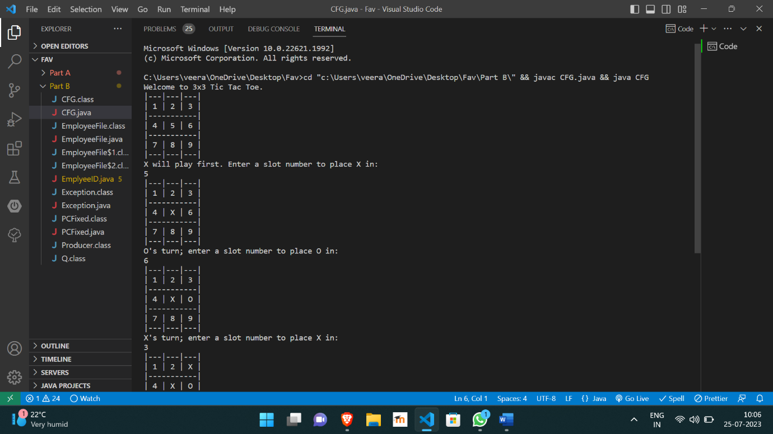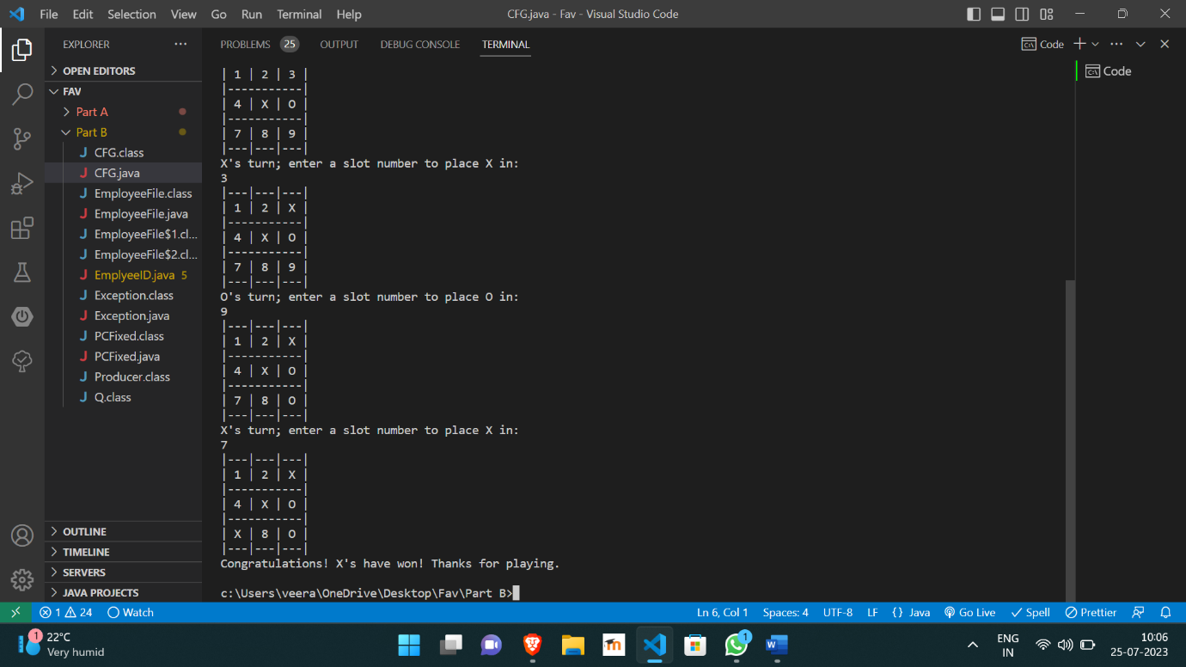

https://github.com/Veeragoutham04/Java_Lab/blob/main/Tic%20Tac%20Toe